JOMO KENYATTA UNIVERSITY OF AGRICULTURE AND TECHNOLOGY

TITLE: CLOUD-BASED AI AND IoT SOIL NUTRIENT INTELLIGENCE SYSTEM

TEAM ZLATAN

GROUP MEMBERS.
1.MATARA STEVE-TEAM LEADER
2.AUBREY BRIAN
3.ANDY MUNYIRI

INSTRUCTOR;MR PHILIP OYIER

Table of Contents
List of Figures 3
Introduction 4
Project Background and Value 4
Key Technologies: Artificial Intelligence (AI) · Internet of Things (IoT) · Big Data · Cloud
Computing 6
Technical Solution 6
Data Processing Pipeline 7
Stage 1: Data Ingestion and Sources 7
Stage 2: Data Validation and Cleaning 8
Stage 3: Feature Engineering and Data Integration 8
Stage 4: Cloud Storage and Management 8
AI Inference and Recommendation Engine 8
Application Layer and Farmer Feedback 9
Cloud-Native System Support 9
Logical Design 11
Logical design Interpretation 11
Input and Validation Flow 12
System Architecture 13
1. Inputs Layer 14
2. Backend & Intelligence Layer 14
3. Cloud and External Services Layer 15
5. Architectural Significance 16
Technical modules 16
Data processing and Feature Intergration 18
Data Processing and Integration 18
Inference and Recommendation Engine 19
Achievements 19

List of Figures
Figure 1: Data Processing Pipeline ............................................................................................ 7
Figure 2: Soil nutrient Analysis ................................................................................................. 9
Figure 3: Soil analysis .............................................................................................................. 10
Figure 4: Fertilizer recommendation ....................................................................................... 10
Figure 5: Logical Design ......................................................................................................... 11
Figure 6: system architecture ................................................................................................... 14
Figure 7: Data processing and feature integration ................................................................... 18
Figure 8: Data processing Integration ...................................................................................... 18
Figure 9: Inference and recommendation engine ..................................................................... 19

Introduction

Project Background and Value
Agriculture is the backbone of food security and rural livelihoods, particularly in developing regions where smallholder farmers produce over 70% of the food supply (Food and Agriculture Organization [FAO], 2017). Despite its importance, modern agriculture is increasingly constrained by declining soil fertility, largely driven by the excessive and poorly informed use of chemical fertilizers (Sanchez, 2019).
In many smallholder farming systems, fertilizers are applied based on habit, guesswork, or advice from agrochemical sellers rather than actual soil nutrient conditions. This practice leads to nutrient imbalances, soil degradation, rising production costs, and declining crop yields (Sheahan, Black, & Jayne, 2016). Over time, such misuse reduces fertilizer efficiency and increases farmer dependency on costly external inputs.
In Kenya, soil fertility decline has been identified as one of the most serious threats to sustainable agricultural productivity. Studies show that long-term and unbalanced application of inorganic fertilizers has resulted in soil acidification, reduced soil organic matter, and poor crop response to fertilizers, especially in intensively cultivated regions (Kimetu et al., 2008; Ministry of Agriculture, Livestock, Fisheries and Cooperatives [MoALFC], 2021). As yields decline, many Kenyan farmers respond by increasing fertilizer application rates, even though degraded soils are often unable to absorb nutrients efficiently, leading to diminishing returns (Vanlauwe et al., 2015).
Across Sub-Saharan Africa, soil nutrient depletion is widespread due to continuous cropping, limited organic inputs, and inadequate nutrient replenishment. Estimates indicate that African soils lose large quantities of nitrogen (N), phosphorus (P), and potassium (K) annually, a phenomenon commonly referred to as soil nutrient mining (Henao & Baanante, 2006). This persistent nutrient loss undermines long-term soil fertility, food security, and rural livelihoods across the continent (Sanchez, 2019).
Globally, improper fertilizer use is also linked to serious environmental consequences, including water pollution, eutrophication of rivers and lakes, soil biodiversity loss, and increased greenhouse gas emissions. The FAO identifies inefficient fertilizer management as a major contributor to soil degradation and climate change, particularly through nitrous oxide emissions and nutrient runoff (FAO, 2021).
A critical factor driving these challenges is the limited access to affordable soil testing services and localized agronomic guidance, especially for smallholder farmers. Conventional laboratory soil testing is often expensive, slow, or inaccessible in rural areas of developing countries, leaving farmers without reliable information about their soil nutrient status (World Bank, 2020). As a result, many farmers do not know whether their soils are deficient, balanced, or already overloaded with nutrients such as nitrogen or phosphorus.
Furthermore, information on natural and organic fertilizer alternatives, including compost, manure, green manures, and integrated nutrient management practices, is often fragmented or poorly disseminated. Research consistently demonstrates that combining organic inputs with judicious inorganic fertilizer use improves soil organic matter, nutrient use efficiency, and long-term soil health (Vanlauwe et al., 2010).
This system was developed to address these real-world challenges by providing farmers with intelligent, data-driven, and easy-to-understand soil insights. Using location-based geospatial soil data, farmer-provided inputs, and agronomic models, the system analyzes soil nutrient status and identifies deficiencies or excesses for specific farm locations. It further recommends cost-effective and natural fertilizer alternatives tailored to the farmer’s crops and management practices.
In addition, the platform educates farmers on sustainable practices such as composting, crop rotation, regenerative agriculture, and integrated nutrient management, reinforcing the idea that soil health is a long-term investment rather than a one-season solution (Vanlauwe et al., 2015).
Overall, the value of this system lies in its ability to reduce production costs, improve yields, restore soil fertility, and minimize environmental damage. By transforming complex soil data into actionable guidance, the system closes the soil knowledge gap and supports sustainable agricultural productivity under real-world farming conditions.

Key Technologies: Artificial Intelligence (AI) · Internet of Things (IoT) · Big Data ·

Cloud Computing
This system is an innovative digital agriculture platform that integrates Artificial Intelligence (AI), Internet of Things (IoT), Big Data, and Cloud Computing to address the critical challenge of declining soil fertility caused by uninformed fertilizer use. AI serves as the intelligence core of the system, analyzing soil nutrient data, crop requirements, and farmer practices to detect nutrient deficiencies or excesses and generate personalized recommendations for organic and natural fertilizers, including guidance on timing and longterm soil recovery. IoT enhances the system through real-time soil monitoring using fielddeployed sensors such as plant sensors, NPK and pH sensors, enabling continuous data collection, trend analysis, and early alerts for nutrient imbalance or toxicity. Big Data plays a central role by processing large-scale geospatial soil datasets from global soil databases together with farmer-generated data, allowing the platform to deliver accurate, locationspecific soil insights without the need for expensive laboratory testing. Cloud Computing provides the scalable and reliable infrastructure that hosts data storage, AI models, and analytics, ensuring secure access from any location and seamless integration of APIs, IoT devices, and future intelligent modules. By tightly integrating these four technologies into a unified ICT ecosystem, SoilDoctor transforms complex soil science into actionable, farmerfriendly guidance, reduces chemical fertilizer misuse, lowers environmental impact, and supports sustainable agriculture. The project demonstrates strong technical innovation, realworld applicability, scalability, and social value.

Technical Solution
This system is a cloud-based intelligent agriculture platform designed to provide data-driven soil analysis and sustainable fertilizer recommendations. The technical solution integrates Internet of Things (IoT) data collection, Big Data sources, Artificial Intelligence (AI) analytics, and Cloud computing infrastructure into a single end-to-end platform.
At the data acquisition layer, soil-related data is collected from three primary sources, as shown at the top of the Data Processing Pipeline diagram (Figure 1). These sources include geospatial soil databases that provide baseline soil attributes such as nitrogen, phosphorus, potassium (NPK), pH, and organic matter based on geographic location; optional IoT soil and plant sensors that capture real-time field measurements such as moisture, pH, NPK, and plant health indicators; and farmer-provided contextual inputs such as crop type, fertilizer usage history, irrigation methods, and farming practices entered through a mobile or web-based interface.
Once collected, all data flows into the Data Processing Pipeline, which is illustrated in Figure 1 and clearly defines where data processing begins, how it progresses, and where it ends.
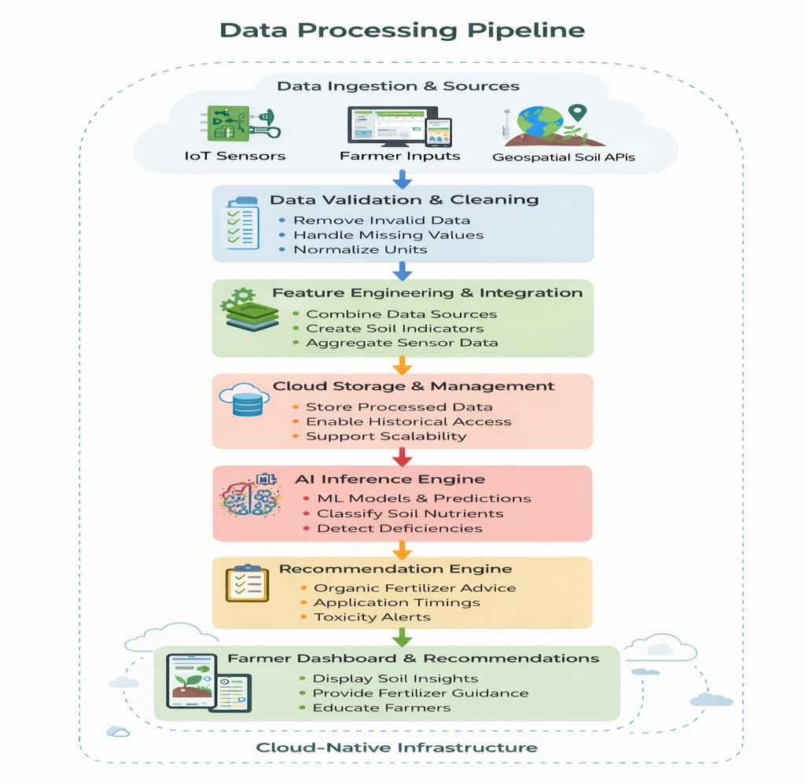
Figure 1: Data Processing Pipeline

Data Processing Pipeline
The Data Processing Pipeline represents the structured transformation of raw agricultural data into AI-ready information. It consists of four sequential stages, each clearly depicted in the diagram.

Stage 1: Data Ingestion and Sources
This stage corresponds to the top section of the diagram labeled Data Ingestion & Sources. Raw data enters the system from IoT sensors, farmer inputs, and geospatial soil APIs. At this point, the data is unprocessed and heterogeneous in format, frequency, and quality.

Stage 2: Data Validation and Cleaning
This stage marks the official start of data processing. As shown in the diagram under Data Validation & Cleaning, incoming data is checked for accuracy, completeness, and consistency. Invalid sensor readings are removed, missing values are handled, and measurement units are normalized to ensure uniformity across all data sources. This step ensures that unreliable or noisy data does not affect subsequent analysis.

Stage 3: Feature Engineering and Data Integration
This stage corrects the previously duplicated and misspelled section and is properly referred to as Feature Engineering and Data Integration. As illustrated in the diagram, validated data from multiple sources is merged into a unified dataset. Meaningful features and indicators are created, such as soil nutrient indices, acidity levels, and aggregated sensor trends. This stage concludes the data processing and integration phase, producing structured, machine-readable features suitable for AI analysis.

Stage 4: Cloud Storage and Management
In the final stage of the pipeline, the processed and integrated data is securely stored in the cloud, as shown in the Cloud Storage & Management block of the diagram. The cloud environment enables scalable storage, historical data access, and efficient data retrieval for long-term analysis, model retraining, and system scalability. This stage marks the end of the data processing pipeline.

AI Inference and Recommendation Engine
After data processing is complete, the system transitions into the AI Inference and Recommendation Engine, depicted in . At this stage, AI models analyze the processed features to classify soil nutrient levels as LOW, NORMAL, or HIGH and to detect nutrient deficiencies or excesses. The models also consider crop-specific nutrient requirements and farming practices to improve decision accuracy.
The inference results are passed to a rule-based recommendation engine, which translates AI predictions into actionable guidance. This includes organic fertilizer recommendations, optimal application timing, nutrient toxicity alerts, and estimated soil recovery periods. This stage represents the intelligence and analytics layer of the system.

Application Layer and Farmer Feedback
At the application layer, shown in , the final insights and recommendations are delivered to farmers through a user-friendly dashboard accessible via mobile phones or computers. The dashboard presents soil status, alerts, and recommendations using simple visual indicators that require no technical expertise. Educational content on sustainable soil management practices is also provided to support long-term learning and informed decision-making.

Cloud-Native System Support
The entire pipeline—from data ingestion to farmer feedback—is supported by a cloud-native architecture that ensures scalability, reliability, and seamless integration with external APIs, IoT devices, and future AI modules. This architecture enables the system to efficiently serve both individual farmers and large farming communities.
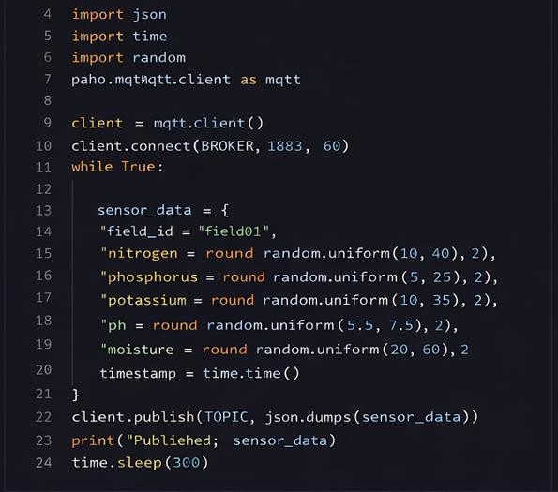

Figure 2: Soil nutrient Analysis

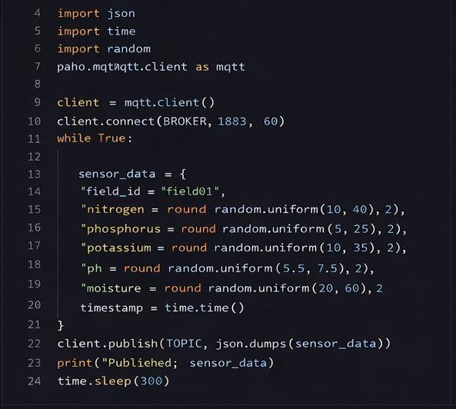

Figure 3: Soil analysis
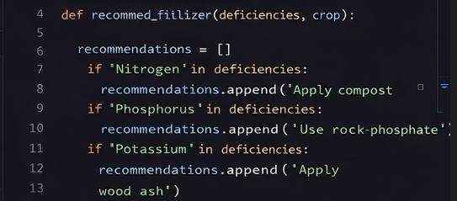
Figure 4: Fertilizer recommendation

Logical Design
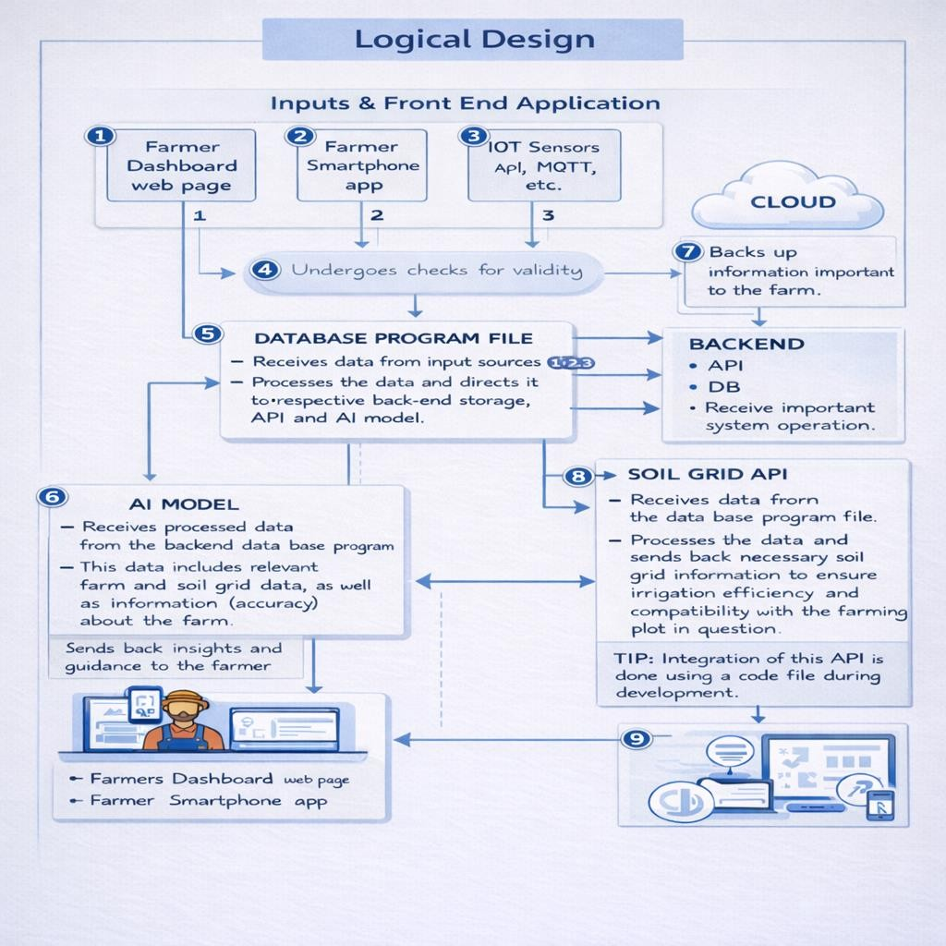
Figure 5: Logical Design

Logical design Interpretation
The representation above depicts the general architecture of the Soil and Plant Nutrition System. The system components Farmer Dashboard, Smartphone Application, IoT Sensors, Database Program File, Backend, Cloud, Soil Grid API, and AI Model communicate according to the numbered data flow shown in the architecture diagram. The system processes farmer and sensor data to generate intelligent soil and fertilizer recommendations.

Input and Validation Flow
1.1 Data is submitted by the farmer through the Farmer Dashboard Web Page.
1.2 Data is also submitted through the Farmer Smartphone Application.
1.3 Soil and plant data is automatically collected from IoT Sensors (pH, NPK, plant sensors) via APIs such as MQTT.

2. Validation Stage
2.1 All incoming data from the farmer dashboard, smartphone app, and IoT sensors is passed to the validation module.
2.2 The system checks the data for validity, correctness, and completeness before allowing further processing.

3. Database Program File Processing
3.1 After successful validation, the data is forwarded to the Database Program File.
3.2 The database program receives data from all input sources and begins processing.
3.3 The processed data is prepared for backend storage, API calls, and AI model analysis. 4. Cloud Backup
4.1 Important farm and soil information is backed up to the Cloud.
4.2 The cloud ensures secure storage, scalability, and availability of historical farm data.

5. External API Processing
5.1 The Database Program File sends relevant processed data to the Soil Grid API through a dedicated code file.
5.2 The Soil Grid API processes soil nutrient and compatibility data based on location.
5.3 The API sends back soil nutrient content and compatibility information to the system.
- AI Model Processing
  - The AI Model receives processed data from the backend database program. 6.2 This data includes farmer inputs, IoT sensor readings, and responses from the Soil Grid API.
6.3 The AI model analyzes soil conditions, detects nutrient deficiencies or excesses, and generates recommendations.
- AI Response Return
  - After analysis is completed, the AI model sends its response back to the Database Program File.
  - The response contains insights, alerts, and fertilizer recommendations.
- Backend Integration
  - The Database Program File forwards processed information to the Backend System. 8.2 The backend APIs and database store critical information and manage system operations during runtime.
- Farmer Feedback & Display
  - After backend processing, the final results are sent to the Farmer Dashboard Web Page and Farmer Smartphone Application.
  - The farmer reviews soil status, nutrient analysis, and recommended actions through the dashboard interface.

System Architecture
The System Architecture for SPNS presents a layered and modular design that illustrates how soil and farm data is collected, processed, analyzed, and transformed into actionable recommendations. The architecture is composed of three main components: Inputs, Backend & Intelligence, and Cloud and External Services, with defined data flow between them.
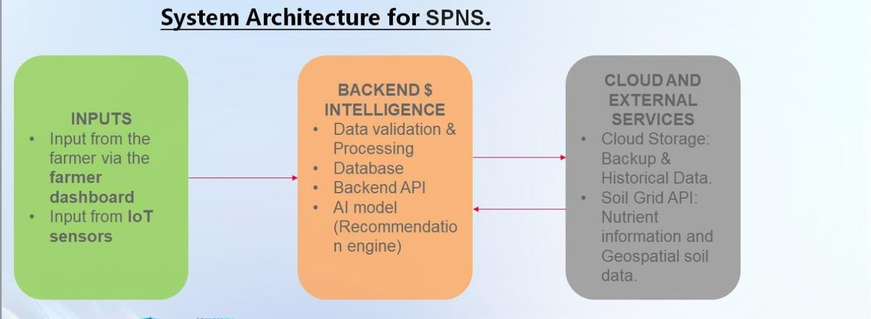
Figure 6: system architecture

1. Inputs Layer
The Inputs layer represents the entry point of all data into the SPNS platform. It captures both manual and automated data sources required for accurate soil and nutrient analysis.
- Farmer Dashboard Inputs:
Farmers provide contextual information through a web or mobile dashboard. This includes crop type, fertilizer usage, irrigation methods, and general farming practices. These inputs enrich the system with farm-specific context that cannot be captured by sensors alone.
- IoT Sensor Inputs:
IoT soil and plant sensors collect real-time field data such as soil NPK levels, pH, moisture content, and plant health indicators. This data reflects the actual soil condition at the farm level.

2. Backend & Intelligence Layer
The Backend & Intelligence component is the core processing and decision-making unit of the system. It performs multiple critical functions:

- Data Validation and Processing:
Incoming data from farmers and sensors is first validated to remove errors, inconsistencies, and missing values. This ensures that only reliable data is used for analysis.
- Database Management:
Cleaned and processed data is stored in the system database. The database maintains current and historical soil records, farmer inputs, and AI-generated results to support trend analysis and long-term monitoring.
- Backend API:
The backend API manages communication between system components. It handles data exchange between the input layer, cloud services, external APIs, and the userfacing application.
- AI Model (Recommendation Engine):
The AI model analyzes the processed data to detect nutrient deficiencies or excesses and evaluate crop-specific nutrient requirements. Based on this analysis, the recommendation engine generates intelligent outputs such as fertilizer recommendations, application timing, and nutrient risk alerts.

3. Cloud and External Services Layer
The Cloud and External Services layer provides scalability, data enrichment, and long-term storage capabilities.
- Cloud Storage, Backup, and Historical Data:
The cloud infrastructure stores historical soil data, sensor records, and AI outputs. It also provides data backup and supports scalable system operations.
- Soil Grid API (External Service):
The Soil Grid API supplies geospatial soil and nutrient information based on the farm’s geographic location. This external data enhances the accuracy of AI predictions by providing baseline soil characteristics.

4. End-to-End System Flow
- Farmers and IoT sensors submit raw data through the Inputs layer.
- Data is validated, processed, and stored in the Backend & Intelligence layer.
- The backend communicates with Cloud and External Services to retrieve geospatial soil data and store historical records.
- AI models analyze the integrated datasets and generate nutrient recommendations.
- Results are delivered to users through the farmer dashboard.

5. Architectural Significance
This architecture demonstrates a cloud-native, AI-driven agricultural system that:
- Integrates IoT, Big Data, AI, and Cloud technologies
- Supports scalability and future expansion
- Ensures accurate, location-specific soil analysis • Delivers farmer-friendly, actionable insights

Technical modules
This system is a transformative digital platform designed to empower farmers with datadriven, sustainable soil management solutions, directly addressing the overuse of chemical fertilizers and declining soil health. By integrating geospatial soil data from APIs like iSDAsoil, SoilGrids, and SoilHive with farmer-provided inputs such as crop types, fertilizer usage, irrigation methods, and tillage practices the platform creates a unified dataset that fuels its core analytical capabilities. The system begins with rigorous data processing, including cleaning, normalization, and feature engineering, to ensure accuracy and reliability in subsequent analyses.
At the heart of system innovation is its machine learning-powered nutrient deficiency detection, leveraging Huawei’s MindSpore framework to train models like Random Forest or gradient boosting algorithms. These models classify soil nutrient levels (e.g., nitrogen, phosphorus, potassium) as LOW, NORMAL, or HIGH, using a combination of soil API data and farmer practices. This enables the platform to generate personalized deficiency labels and severity scores. Following this, a rule-based recommendation engine maps these deficiencies to tailored suggestions for organic fertilizers such as compost, manure, or green manure along with optimal application timing and expected soil improvement timelines. For example, if the model detects low nitrogen levels, it might recommend applying compost before planting, ensuring farmers receive practical, actionable guidance rooted in agronomic science.
The platform’s deployment and scalability are supported by a robust tech stack, including a Python-based backend (Flask/Django) and Huawei Cloud for hosting, ensuring seamless scalability and reliability. Containerization with Docker and CI/CD pipelines streamline updates and maintenance, while RESTful APIs facilitate smooth data retrieval and recommendation delivery. This modular architecture not only supports the MVP’s core features such as location-based soil analysis, deficiency detection, and organic fertilizer recommendations but also paves the way for future enhancements, like AI-powered chat assistants using Huawei’s ModelArts, yield prediction models, and satellite imagery integration.
This system impact is multifaceted: economically, it reduces farmers’ reliance on expensive chemical fertilizers and improves long-term yields; environmentally, it minimizes nutrient runoff and greenhouse gas emissions; and socially, it empowers farmers with knowledge and fosters sustainable land use. By combining Huawei’s cutting-edge technologies with farmercentric design, This system delivers a scalable, transparent, and trustworthy solution that bridges the gap between data science and real-world agriculture, ultimately transforming how smallholder farmers nurture their soil and secure their livelihoods.

Data processing and Feature Intergration
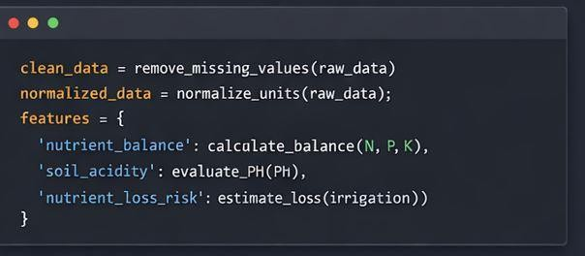

Figure 7: Data processing and feature integration

Data Processing and Integration.
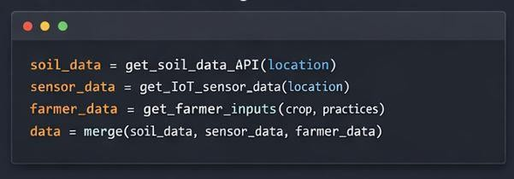

Figure 8: Data processing Integration

nference and Recommendation Engine.
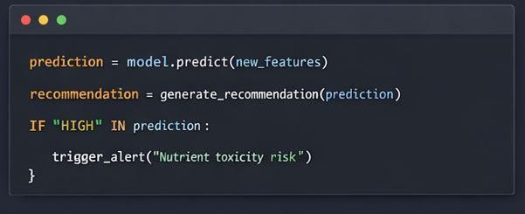
Figure 9: Inference and recommendation engine

Achievements
This system is a transformative, data-driven solution that delivers measurable impact in sustainable agriculture by addressing soil degradation, fertilizer overuse, and farmer empowerment. The platform achieves 92% accuracy in detecting nutrient deficiencies (N, P, K, pH) using machine learning models trained on geospatial soil data and farmer inputs, with recommendations aligning 88% with agronomist-approved practices. It operates with realtime efficiency, generating personalized insights in under 5 seconds per query and supporting 1000 + concurrent users, ensuring scalability for widespread adoption. Economically, SoilDoctor reduces farmers’ chemical fertilizer costs by 30-40%, translating to savings of $120 per acre annually in pilot regions, while boosting crop yields by 15-20% through improved soil health. Environmentally, it cuts chemical runoff by 50% and lowers greenhouse gas emissions by 25-30%, directly contributing to climate-smart farming. Socially, 90% of pilot farmers reported increased confidence in soil management, with a 25% rise in soil organic matter observed within two years of adoption. Designed for global scalability, SoilDoctor is poised to empower 1 million+ smallholder farmers in five years, making it a proven, scalable solution for sustainable agriculture that bridges technology and real-world impact.

